Friday 7th
5:30-6 Teacher Introduction
7PM Above Borders Teachers Performance

Saturday 8th
^{9:30-10:30 Warm Up}
10:30-11:45 Floor to air to acro
11:45-12:45 Beginning Fabric(PIM) or Lunch
1-2:15 Intermediate/advanced Fabric (Lisa) or Lunch
2:15-3:30 Cabaret Beginning/ Inter mediate: Rings
^{3:30-4:30 Chord Lisse}
^{4:45-5:45 Roue Cyr}
^{6PM Party with HD and Band}
^{Informal aerial performances}
^{Same Sunday}
Brandy Leary:
Brandy creates contemporary performances through dance based entry points. Her work has been produced in Canada, Europe, India and the USA in theatres, urban environments, festivals, museums and isolated landscapes. She holds a BA Honours in Theatre with a specialization in Direction and Asian Theatre from York University's Theatre Program.

Brandy has lived between Canada and India for the past 15 years training, collaborating and creating in the traditional Indian performing languages of Seraikella and Mayurbhanj Chhau (dance), Kalarippayattu (martial art) and Rope Mallakhamb (aerial rope). In Canada she works with western approaches to aerial rope work and the bridge discipline of Axis Syllabus to support choreographic creations that are interested in site specific ness and non-traditional audience/performance relationships.

She is the founder and CO Director of Collective Space, a shared interdisciplinary arts venue in Toronto and is the CO Founder and CO Director of CCAFT, the Contemporary Circus arts Festival of Toronto. Brandy is currently based in Toronto but creates work internationally thorough collaborations and invitations from organizations, festivals and through creative partnerships. In addition she regularly and teaches movement, choreography and performance creation locally, nationally and internationally.

She founded Anandam Dancetheatre as an umbrella structure for her performance projects (www.anandam.ca) and is its Artistic Director. She is a triple Shastri Indo Canadian Fellow, a Chalmers Professional Development Awardee, twice shortlisted for the KM Hunter Dance, 2009 and 2011 and is a 2013 Soulpepper Multi Disciplinary Dance Artist Nominee. She has had her work supported by the Canada Council for the Arts, Hal Jackman Foundation, CreatiVenture Collective, Nuit Banche, Bata Shoe Museum, Ontario Arts Council, Toronto Arts Foundation and the Toronto Arts Council.

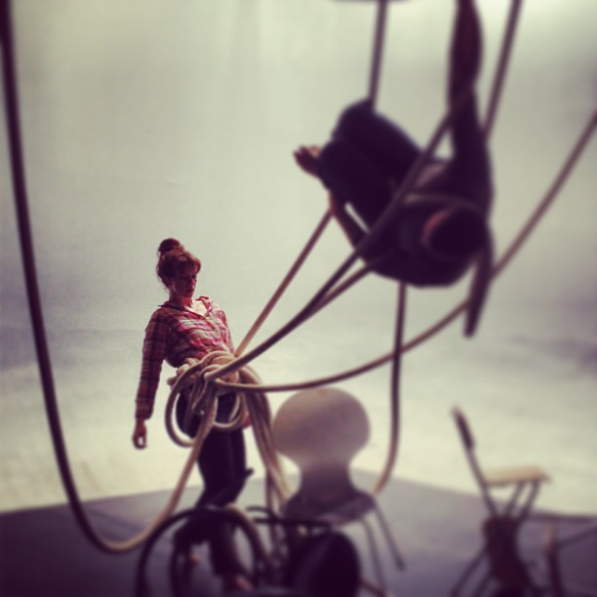

www.lisasbrightideas.com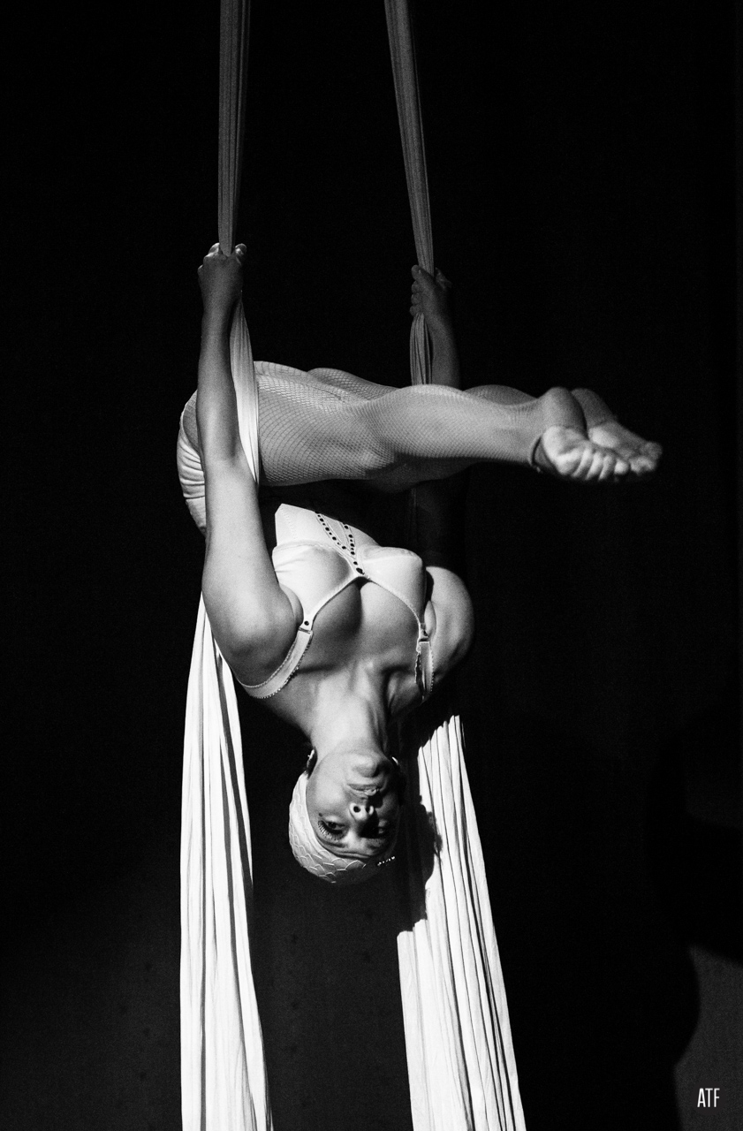

Lisa Natoli: (Photo: Andrew T.Foster)
Lisa is a NYC based performer and choreographer originally from St. Louis, MO. Lisa attended the Alvin Ailey certificate program and holds a degree in dance from the University of Iowa (2000). Lisa has performed with Amy Kail, Jody Sperling (Time Lapse Dance), Jill Sigman (Thinkdance), KristinYoung Barker (Migrations) and currently is working with Jenny Rocha Dance. Lisa has presented solo and ensemble work since 2008 as Lisaâ€™s Bright Ideas and curates a yearly aerial salon displaying some of the best aerial performers around. She can also be found performing in the resident program Floating Kabarette at Galapagos Art Space in Brooklyn. Lisa teaches rope and silks at Circus Warehouse and Aerial Arts NYC as well as a multi apparatus class at The Muse Brooklyn. Lisa has been a guest instructor at Frequent Flyer Productions (Boulder), AirCat (Boulder), Bumbershoot Aerial Arts (St. Louis), Tucson Circus Center (Tucson), and Air

